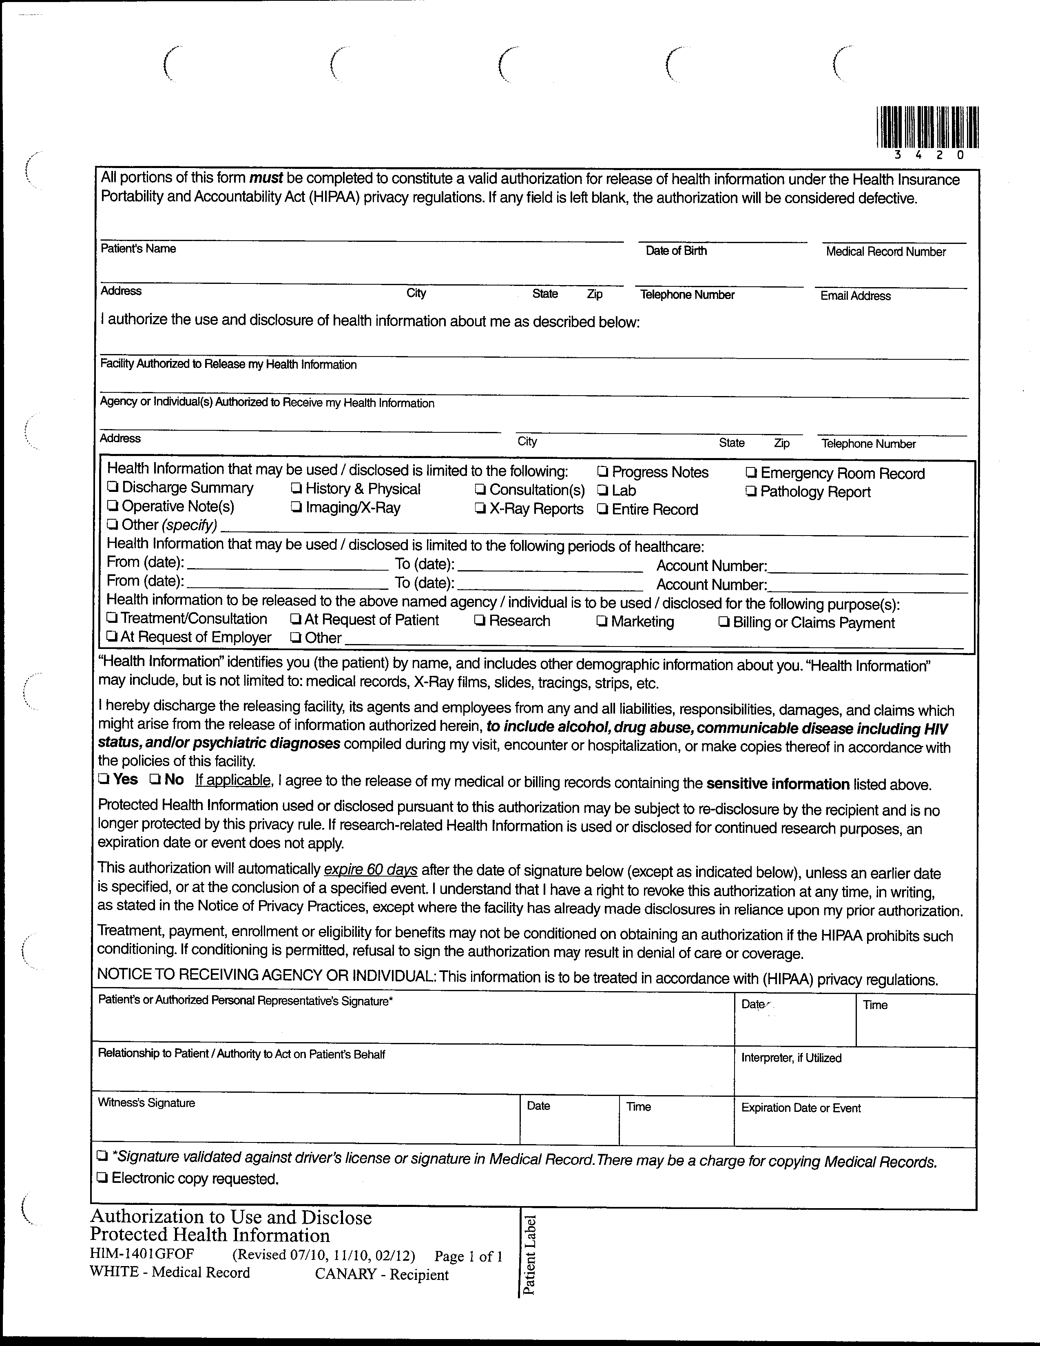
USE FOR WILLIAM DEARBAUGH:FROM 01/01/1979 TO PRESENT: Any and all MEDICAL RECORDS and FILMS (ON CD IF AVAILABLE). FROM TO PRESENT: BILLING RECORDS including but not limited to patient history form(s), and itemized write offs and billing payments, etc. pertaining to Batman SSN: xxx-xx-5555, DOB: 01/01/1979.
Axiom Requisition Copy Service
2869 Jolly Road Okemos MI 48864
(877) 886-5090
Order Number: 01-29018-001
Batman
Secret Location Under Office Building Gotham, NJ
01/01/1979
Gotham City Hospital Anesthesiology
X

